***University Physics Volume I***

**Unit 1: Mechanics**

**Chapter 9: Linear Momentum and Collisions**

**Conceptual Questions**

1. An object that has a small mass and an object that has a large mass have the same momentum. Which object has the largest kinetic energy?

Solution

Since  then if the momentum is fixed, the object with smaller mass has more kinetic energy.

1. An object that has a small mass and an object that has a large mass have the same kinetic energy. Which mass has the largest momentum?

Solution

The object with larger mass must have the larger momentum to have the same kinetic energy.

1. Is it possible for a small force to produce a larger impulse on a given object than a large force? Explain.

Solution

Yes; impulse is the force applied multiplied by the time during which it is applied (), so if a small force acts for a long time, it may result in a larger impulse than a large force acting for a small time.

1. Why is a 10-m fall onto concrete far more dangerous than a 10-m fall onto water?

Solution

The concrete will reduce your momentum to zero in a very short time compared with water, so it must exert a much greater average force on your body because 

1. What external force is responsible for changing the momentum of a car moving along a horizontal road?

Solution

By friction, the road exerts a horizontal force on the tires of the car, which changes the momentum of the car.

1. A piece of putty and a tennis ball with the same mass are thrown against a wall with the same velocity. Which object experiences a greater force from the wall or are the forces equal? Explain.

Solution

The tennis ball most likely experiences a larger-magnitude force than the putty. We make the reasonable assumption that the interaction time  with the wall is the same for both and assume both have the same initial momentum . The final momentum of the putty is zero, so  The tennis ball bounces off the wall, so we can assume that the final momentum of the tennis ball is, so . The magnitude of the forces received by the two objects are  and . Thus, the magnitude of the force received by the tennis ball is roughly twice that received by the putty.

1. Under what circumstances is momentum conserved?

Solution

Momentum is conserved when the mass of the system of interest remains constant during the interaction in question and when no *net* external force acts on the system during the interaction.

1. Can momentum be conserved for a system if there are external forces acting on the system? If so, under what conditions? If not, why not?

Solution

Yes, momentum can be conserved even if external forces act on the system, provided that those forces cancel so that the *net* external force is zero.

1. Explain in terms of momentum and Newton’s laws how a car’s air resistance is due in part to the fact that it pushes air in its direction of motion.

Solution

To accelerate air molecules in the direction of motion of the car, the car must exert a force on these molecules by Newton’s second law . By Newton’s third law, the air molecules exert a force of equal magnitude but in the opposite direction on the car. This force acts in the direction opposite the motion of the car and constitutes the force due to air resistance.

1. Can objects in a system have momentum while the momentum of the system is zero? Explain your answer.

Solution

Yes, the momentum of a system can be zero even if the objects composing the system have nonzero momentum if the vector sum of the momentum of these objects sums to zero (i.e., their momenta cancel out).

1. A sprinter accelerates out of the starting blocks. Can you consider him as a closed system? Explain.

Solution

No, he is not a closed system because a net nonzero external force acts on him in the form of the starting blocks pushing on his feet.

1. A rocket in deep space (zero gravity) accelerates by firing hot gas out of its thrusters. Does the rocket constitute a closed system? Explain.

Solution

No, the rocket is not a closed system. Although no external forces act on the rocket, its mass changes as it fires gas out of its thrusters.

1. Two objects of equal mass are moving with equal and opposite velocities when they collide. Can all the kinetic energy be lost in the collision?

Solution

Yes, all the kinetic energy can be lost if the two masses come to rest due to the collision (i.e., they stick together).

1. Describe a system for which momentum is conserved but mechanical energy is not. Now the reverse: Describe a system for which kinetic energy is conserved but momentum is not.

Solution

A system in which momentum is conserved but not mechanical energy could be two balls of putty of the same mass and opposite initial velocities that collide and stick together. A system in which momentum is not conserved does not exist because, a change in momentum requires a net external force but, by definition, such a force would come from outside the system and so is not part of the system. Note that mechanical energy is conserved in closed systems in which all collisions are elastic.

1. Momentum for a system can be conserved in one direction while not being conserved in another. What is the angle between the directions? Give an example.

Solution

The angle between the directions must be 90°. Any system that has zero net external force in one direction and nonzero net external force in a perpendicular direction will satisfy these conditions.

1. Suppose a fireworks shell explodes, breaking into three large pieces for which air resistance is negligible. How does the explosion affect the motion of the center of mass? How would it be affected if the pieces experienced significantly more air resistance than the intact shell?

Solution

Neglecting air resistance, which is an external force, the center of mass of the shell after the explosion continues to move in the same parabolic trajectory due to gravity as it did before the explosion. If we consider air resistance to be significant, then the motion of the center of mass will drop below the parabolic trajectory.

1. It is possible for the velocity of a rocket to be greater than the exhaust velocity of the gases it ejects. When that is the case, the gas velocity and gas momentum are in the same direction as that of the rocket. How is the rocket still able to obtain thrust by ejecting the gases?

Solution

Yes, the rocket speed can exceed the exhaust speed of the gases it ejects. The thrust of the rocket does not depend on the relative speeds of the gases and rocket, it simply depends on conservation of momentum.

**Problems**

1. An elephant and a hunter are having a confrontation.

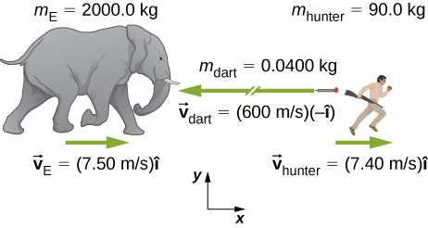

* 1. Calculate the momentum of the 2000.0-kg elephant charging the hunter at a speed of 7.50 m/s.
  2. Calculate the ratio of the elephant’s momentum to the momentum of a 0.0400-kg tranquilizer dart fired at a speed of 600 m/s.
  3. What is the momentum of the 90.0-kg hunter running at 7.40 m/s after missing the elephant?

Solution

a.  ; b. Greater by a factor of 625; c. 

1. A skater of mass 40 kg is carrying a box of mass 5 kg. The skater has a speed of 5 m/s with respect to the floor and is gliding without any friction on a smooth surface.
2. Find the momentum of the box with respect to the floor.
3. Find the momentum of the box with respect to the floor after she puts the box down on the frictionless skating surface.

Solution

a. magnitude:  b. same as a.

1. A car of mass 2000 kg is moving with a constant velocity of 10 m/s due east. What is the momentum of the car?

Solution

 due east

1. The mass of Earth is  and its orbital radius is an average of . Calculate the magnitude of its linear momentum at the location in the diagram.

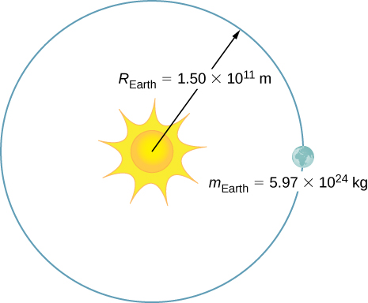

Solution



1. If a rainstorm drops 1 cm of rain over an area of 10 km2 in the period of 1 hour, what is the momentum of the rain that falls in one second? Assume the terminal velocity of a raindrop is 10 m/s.

Solution



1. What is the average momentum of an avalanche that moves a 40-cm-thick layer of snow over an area of 100 m by 500 m over a distance of 1 km down a hill in 5.5 s? Assume a density of 350 kg/m3 for the snow.

Solution



1. What is the average momentum of a 70.0-kg sprinter who runs the 100-m dash in 9.65 s?

Solution



1. A 75.0-kg person is riding in a car moving at 20.0 m/s when the car runs into a bridge abutment (see the following figure).

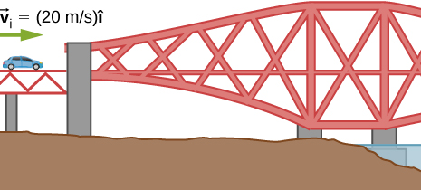

* 1. Calculate the average force on the person if he is stopped by a padded dashboard that compresses an average of 1.00 cm.
  2. Calculate the average force on the person if he is stopped by an air bag that compresses an average of 15.0 cm.

Solution

a. ; b. 

1. One hazard of space travel is debris left by previous missions. There are several thousand objects orbiting Earth that are large enough to be detected by radar, but there are far greater numbers of very small objects, such as flakes of paint. Calculate the force exerted by a 0.100-mg chip of paint that strikes a spacecraft window at a relative speed of , given the collision lasts .

Solution



1. A cruise ship with a mass of  strikes a pier at a speed of 0.750 m/s. It comes to rest after traveling 6.00 m, damaging the ship, the pier, and the tugboat captain’s finances. Calculate the average force exerted on the pier using the concept of impulse. (*Hint*: First calculate the time it took to bring the ship to rest, assuming a constant force.)

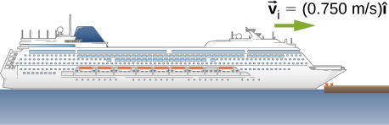

Solution



1. Calculate the final speed of a 110-kg rugby player who is initially running at 8.00 m/s but collides head-on with a padded goalpost and experiences a backward force of  for .

Solution

0.80 m/s

1. Water from a fire hose is directed horizontally against a wall at a rate of 50.0 kg/s and a speed of 42.0 m/s. Calculate the force exerted on the wall, assuming the water’s horizontal momentum is reduced to zero.

Solution



1. A 0.450-kg hammer is moving horizontally at 7.00 m/s when it strikes a nail and comes to rest after driving the nail 1.00 cm into a board. Assume constant acceleration of the hammer-nail pair.
2. Calculate the duration of the impact.
3. What was the average force exerted on the nail?

Solution

a. ; b. 

1. What is the momentum (as a function of time) of a 5.0-kg particle moving with a velocity  What is the net force acting on this particle?

Solution

;

1. The x-component of a force on a 46-g golf ball by a 7-iron versus time is plotted in the following figure:

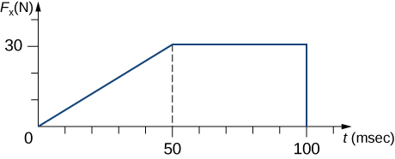

1. Find the x-component of the impulse during the intervals
   * 1. [0, 50 ms], and
     2. [50 ms, 100 ms]
2. Find the change in the x-component of the momentum during the intervals
   * 1. [0, 50 ms], and
     2. [50 ms, 100 ms]

Solution

a. i. , ii. ; b. i. , ii. 

1. A hockey puck of mass 150 g is sliding due east on a frictionless table with a speed of 10 m/s. Suddenly, a constant force of magnitude 5 N and direction due north is applied to the puck for 1.5 s. Find the north and east components of the momentum at the end of the 1.5-s interval.

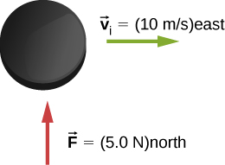

Solution

Let the positive x-axis be in the direction of the original momentum. Then  and 

1. A ball of mass 250 g is thrown with an initial velocity of 25 m/s at an angle of  with the horizontal direction. Ignore air resistance. What is the momentum of the ball after 0.2 s? (Do this problem by finding the components of the momentum first, and then constructing the magnitude and direction of the momentum vector from the components.)

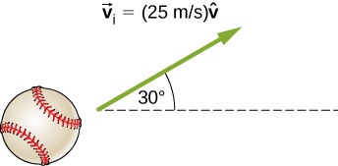

Solution

 at 

1. Train cars are coupled together by being bumped into one another. Suppose two loaded train cars are moving toward one another, the first having a mass of  and a velocity of and the second having a mass of  and a velocity of . What is their final velocity?

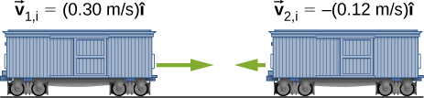

Solution



1. Two identical pucks collide elastically on an air hockey table. Puck 1 was originally at rest; puck 2 has an incoming speed of 6.00 m/s and scatters at an angle of  with respect to its incoming direction. What is the velocity (magnitude and direction) of puck 1 after the collision?

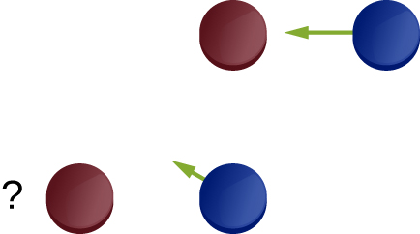

Solution



1. The figure below shows a bullet of mass 200 g traveling horizontally towards the east with speed 400 m/s, which strikes a block of mass 1.5 kg that is initially at rest on a frictionless table.

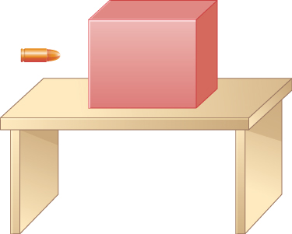

After striking the block, the bullet is embedded in the block and the block and the bullet move together as one unit.

* 1. What is the magnitude and direction of the velocity of the block/bullet combination immediately after the impact?
  2. What is the magnitude and direction of the impulse by the block on the bullet?
  3. What is the magnitude and direction of the impulse from the bullet on the block?
  4. If it took 3 ms for the bullet to change the speed from 400 m/s to the final speed after impact, what is the average force between the block and the bullet during this time?

Solution

a. 47 m/s in the bullet to block direction; b., toward the bullet; c., toward the block; d. magnitude is 

1. A 20-kg child is coasting at 3.3 m/s over flat ground in a 4.0-kg wagon. The child drops a 1.0-kg ball out the back of the wagon. What is the final speed of the child and wagon?

Solution

3.3 m/s

1. A 4.5 kg puffer fish expands to 40% of its mass by taking in water. When the puffer fish is threatened, it releases the water toward the threat to move quickly forward. What is the ratio of the speed of the puffer fish forward to the speed of the expelled water backwards?

Solution

2:5

1. Explain why a cannon recoils when it fires a shell.

Solution

The initial momentum of the cannon-shell system is zero, so the final momentum must also be zero. Because the shell carries some momentum forward, the cannon must conserve momentum by moving backward.

1. Two figure skaters are coasting in the same direction, with the leading skater moving at 5.5 m/s and the trailing skating moving at 6.2 m/s. When the trailing skater catches up with the leading skater, he picks her up without applying any horizontal forces on his skates. If the trailing skater is 50% heavier than the 50-kg leading skater, what is their speed after he picks her up?

Solution

5.9 m/s

1. A 2000-kg railway freight car coasts at 4.4 m/s underneath a grain terminal, which dumps grain directly down into the freight car. If the speed of the loaded freight car must not go below 3.0 m/s, what is the maximum mass of grain that it can accept?

Solution



1. A 5.50-kg bowling ball moving at 9.00 m/s collides with a 0.850-kg bowling pin, which is scattered at an angle of 15.8° to the initial direction of the bowling ball and with a speed of 15.0 m/s.
   1. Calculate the final velocity (magnitude and direction) of the bowling ball.
   2. Is the collision elastic?

Solution

a. 6.80 m/s, 5.33°; b. yes (calculate the ratio of the initial and final kinetic energies)

1. Ernest Rutherford (the first New Zealander to be awarded the Nobel Prize in Chemistry) demonstrated that nuclei were very small and dense by scattering helium-4 nuclei from gold-197 nuclei. The energy of the incoming helium nucleus was , and the masses of the helium and gold nuclei were  and , respectively (note that their mass ratio is 4 to 197).
2. If a helium nucleus scatters to an angle of  during an elastic collision with a gold nucleus, calculate the helium nucleus’s final speed and the final velocity (magnitude and direction) of the gold nucleus.

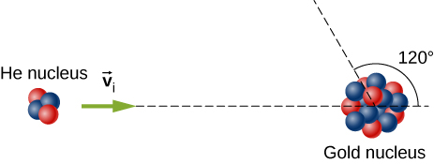

1. What is the final kinetic energy of the helium nucleus?

Solution

(a) , (b) 

1. A 90.0-kg ice hockey player hits a 0.150-kg puck, giving the puck a velocity of 45.0 m/s. If both are initially at rest and if the ice is frictionless, how far does the player recoil in the time it takes the puck to reach the goal 15.0 m away?

Solution

2.5 cm

1. A 100-g firecracker is launched vertically into the air and explodes into two pieces at the peak of its trajectory. If a 72-g piece is projected horizontally to the left at 20 m/s, what is the speed and direction of the other piece?

Solution

51 m/s horizontally to the right

1. In an elastic collision, a 400-kg bumper car collides directly from behind with a second, identical bumper car that is traveling in the same direction. The initial speed of the leading bumper car is 5.60 m/s and that of the trailing car is 6.00 m/s. Assuming that the mass of the drivers is much, much less than that of the bumper cars, what are their final speeds?

Solution

the speed of the leading bumper car is 6.00 m/s and that of the trailing bumper car is 5.60 m/s

1. Repeat the preceding problem if the mass of the leading bumper car is 30.0% greater than that of the trailing bumper car.

Solution

the speed of the leading bumper car is 5.95 m/s and that of the trailing bumper car is 5.55 m/s

1. An alpha particle (4He) undergoes an elastic collision with a stationary uranium nucleus (235U). What percent of the kinetic energy of the alpha particle is transferred to the uranium nucleus? Assume the collision is one-dimensional.

Solution

6.6%

1. You are standing on a very slippery icy surface and throw a 1-kg football horizontally at a speed of 6.7 m/s. What is your velocity when you release the football? Assume your mass is 65 kg.

Solution

0.10 m/s in the direction opposite that of the football

1. A 35-kg child rides a relatively massless sled down a hill and then coasts along the flat section at the bottom, where a second 35-kg child jumps on the sled as it passes by her. If the speed of the sled is 3.5 m/s before the second child jumps on, what is its speed after she jumps on?

Solution

1.8 m/s

1. A boy sleds down a hill and onto a frictionless ice-covered lake at 10.0 m/s. In the middle of the lake is a 1000-kg boulder. When the sled crashes into the boulder, he is propelled backwards from the boulder. The collision is an elastic collision. If the boy’s mass is 40.0 kg and the sled’s mass is 2.50 kg, what is the speed of the sled and the boulder after the collision?

Solution

–9.18 m/s, 0.815 m/s

1. A 0.90-kg falcon is diving at 28.0 m/s at a downward angle of . It catches a 0.325-kg pigeon from behind in midair. What is their combined velocity after impact if the pigeon’s initial velocity was 7.00 m/s directed horizontally? Note that  is a unit vector pointing in the direction in which the falcon is initially flying.

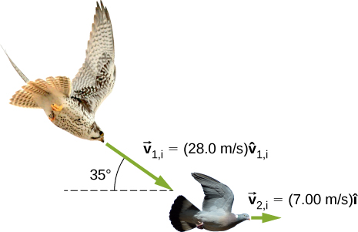

Solution

22.1 m/s at  below the horizontal

1. A billiard ball, labeled 1, moving horizontally strikes another billiard ball, labeled 2, at rest. Before impact, ball 1 was moving at a speed of 3.00 m/s, and after impact it is moving at 0.50 m/s at 50° from the original direction. If the two balls have equal masses of 300 g, what is the velocity of the ball 2 after the impact?

Solution

2.7 m/s, 8.1° below the horizontal direction

1. A projectile of mass 2.0 kg is ﬁred in the air at an angle of 40.0 to the horizon at a speed of 50.0 m/s. At the highest point in its flight, the projectile breaks into three parts of mass 1.0 kg, 0.7 kg, and 0.3 kg. The 1.0-kg part falls straight down after breakup with an initial speed of 10.0 m/s, the 0.7-kg part moves in the original forward direction, and the 0.3-kg part goes straight up.

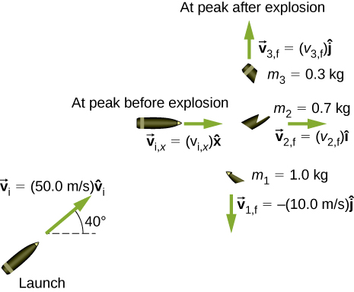

* 1. Find the speeds of the 0.3-kg and 0.7-kg pieces immediately after the break-up.
  2. How high from the break-up point does the 0.3-kg piece go before coming to rest?
  3. Where does the 0.7-kg piece land relative to where it was ﬁred from?

Solution

a. 33 m/s and 110 m/s; b. 57 m; c. 480 m

1. Two asteroids collide and stick together. The first asteroid has mass of  and is initially moving at 770 m/s. The second asteroid has mass of  and is moving at 1020 m/s. Their initial velocities made an angle of 20° with respect to each other. What is the final speed and direction with respect to the velocity of the first asteroid?

Solution

900 m/s, 12.8° with respect to the velocity of first asteroid

1. A 200-kg rocket in deep space moves with a velocity of . Suddenly, it explodes into three pieces, with the first (78 kg) moving at  and the second (56 kg) moving at . Find the velocity of the third piece.

Solution



1. A proton traveling at  scatters elastically from an initially stationary alpha particle and is deflected at an angle of 85° with respect to its initial velocity. Given that the alpha particle has four times the mass of the proton, what percent of its initial kinetic energy does the proton retain after the collision?

Solution

63%

1. Three 70-kg deer are standing on a flat 200-kg rock that is on an ice-covered pond. A gunshot goes off and the dear scatter, with deer A running at , deer B running at , and deer C running at . What is the velocity of the rock on which they were standing?

Solution



1. A family is skating. The father (75 kg) skates at 8.2 m/s and collides and sticks to the mother (50 kg), who was initially moving at 3.3 m/s and at 45° with respect to the father’s velocity. The pair then collides with their daughter (30 kg), who was stationary, and the three slide off together. What is their final velocity?

Solution

4.6 m/s at 9.1° with respect to the father’s initial velocity

1. An oxygen atom (mass 16 u) moving at 733 m/s at 15.0° with respect to the  direction collides and sticks to an oxygen molecule (mass 32 u) moving at 528 m/s at 128° with respect to the  direction. The two stick together to form ozone. What is the final velocity of the ozone molecule?

Solution

341 m/s at 86.8° with respect to the  axis.

1. Two cars of the same mass approach an extremely icy four-way perpendicular intersection. Car A travels northward at 30 m/s and car B is travelling eastward. They collide and stick together, traveling at 28° north of east. What was the initial velocity of car B?

Solution

56 m/s eastward

1. Three point masses are placed at the corners of a triangle as shown in the figure below.

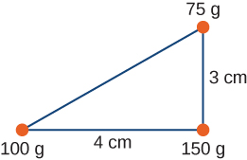

Find the center of mass of the three-mass system.

Solution

With the origin defined to be at the position of the 150-g mass,  and 

1. Two particles of masses  and  separated by a horizontal distance *D* are released from the same height *h* at the same time. Find the vertical position of the center of mass of these two particles at a time before the two particles strike the ground. Assume no air resistance.

Solution



1. Two particles of equal masses  and  separated by a horizontal distance *D* are let go from the same height *h* at different times. Particle 1 starts at , and particle 2 is let go at . Find the vertical position of the center of mass at a time before the first particle strikes the ground. Assume no air resistance.

Solution



1. Two particles of masses  and  move uniformly in different circles of radii  and  about origin in the *x*,*y*-plane. The *x*- and *y*-coordinates of the center of mass and that of particle 1 are given as follows (where length is in meters and *t* in seconds):



and:



* 1. Find the radius of the circle in which particle 1 moves.
  2. Find the *x*- and *y*-coordinates of particle 2 and the radius of the circle this particle moves.

Solution

a. 4 m; b. , , with, then 

1. Two particles of masses  and  move uniformly in different circles of radii  and about the origin in the *x*,*y*-plane. The coordinates of the two particles in meters are given as follows ( for both). Here *t* is in seconds:



1. Find the radii of the circles of motion of both particles.
2. Find the *x*- and *y*-coordinates of the center of mass.
3. Decide if the center of mass moves in a circle by plotting its trajectory.

Solution

a.  , ; b. ; c. yes, with 

1. Find the center of mass of a one-meter long rod, made of 50 cm of iron (density ) and 50 cm of aluminum (density ).

Solution

12.6 cm from the center of the iron rod towards the aluminum rod

1. Find the center of mass of a rod of length *L* whose mass density changes from one end to the other quadratically. That is, if the rod is laid out along the *x*-axis with one end at the origin and the other end at , the density is given by , where  and  are constant values.

Solution



1. Find the center of mass of a rectangular block of length *a* and width *b* that has a nonuniform density such that when the rectangle is placed in the *x*,*y*-plane with one corner at the origin and the block placed in the first quadrant with the two edges along the *x*- and *y*-axes, the density is given by, where  is a constant.

Solution



1. Find the center of mass of a rectangular material of length *a* and width *b* made up of a material of nonuniform density. The density is such that when the rectangle is placed in the *xy*-plane, the density is given by 

Solution



1. A cube of side *a* is cut out of another cube of side *b* as shown in the figure below.

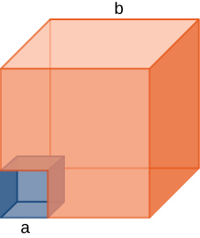

Find the location of the center of mass of the structure. (*Hint:* Think of the missing part as a negative mass overlapping a positive mass.)

Solution

Assume origin is at lower left corner of cube, then

1. Find the center of mass of cone of uniform density that has a radius *R* at the base, height *h*, and mass *M*. Let the origin be at the center of the base of the cone and have +*z* going through the cone vertex.

Solution



1. Find the center of mass of a thin wire of mass *m* and length *L* bent in a semicircular shape. Let the origin be at the center of the semicircle and have the wire arc from the +*x* axis, cross the +*y* axis, and terminate at the −*x* axis.

Solution



1. Find the center of mass of a uniform thin semicircular plate of radius *R*. Let the origin be at the center of the semicircle, the plate arc from the +*x* axis to the −x axis, and the *z* axis be perpendicular to the plate.

Solution



1. Find the center of mass of a sphere of mass *M* and radius *R* and a cylinder of mass *m*, radius *r*, and height *h* arranged as shown below.

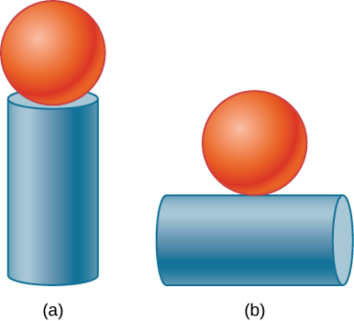

Express your answers in a coordinate system that has the origin at the center of the cylinder.

Solution

a. ; b. 

1. (a) A 5.00-kg squid initially at rest ejects 0.250 kg of fluid with a velocity of 10.0 m/s. What is the recoil velocity of the squid if the ejection is done in 0.100 s and there is a 5.00-*N* frictional force opposing the squid’s movement?

(b) How much energy is lost to work done against friction?

Solution

(a) 0.413 m/s, (b) about 0.2 J

1. A rocket takes off from Earth and reaches a speed of 100 m/s in 10.0 s. If the exhaust speed is 1500 m/s and the mass of fuel burned is 100 kg, what was the initial mass of the rocket?

Solution

809 kg

1. Repeat the preceding problem but for a rocket that takes off from a space station, where there is no gravity other than the negligible gravity due to the space station.

Solution

1551 kg

1. How much fuel would be needed for a 1000-kg rocket (this is its mass with no fuel) to take off from Earth and reach 1000 m/s in 30 s? The exhaust speed is 1000 m/s.

Solution



1. What exhaust speed is required to accelerate a rocket in deep space from 800 m/s to 1000 m/s in 5.0 s if the total rocket mass is 1200 kg and the rocket only has 50 kg of fuel left?

Solution

4.9 km/s

1. **Unreasonable Results** Squids have been reported to jump from the ocean and travel 30.0 m (measured horizontally) before re-entering the water.

(a) Calculate the initial speed of the squid if it leaves the water at an angle of 20.0°, assuming negligible lift from the air and negligible air resistance.

(b) The squid propels itself by squirting water. What fraction of its mass would it have to eject in order to achieve the speed found in the previous part? The water is ejected at 12.0 m/s; gravitational force and friction are neglected.

(c) What is unreasonable about the results?

(d) Which premise is unreasonable, or which premises are inconsistent?

Solution

a. 21.4 m/s, b. 575%, c. The squid cannot eject over five times it mass in water because its mass includes the mass of the water that it ejects. d. The range is much too far.

**Additional Problems**

1. Two 70-kg canoers paddle in a single, 50-kg canoe. Their paddling moves the canoe at 1.2 m/s with respect to the water, and the river they’re in flows at 4 m/s with respect to the land. What is their momentum with respect to the land?

Solution



1. Which has a larger magnitude of momentum: a 3000-kg elephant moving at 40 km/h or a 60-kg cheetah moving at 112 km/h?

Solution

the elephant has a higher momentum

1. A driver applies the brakes and reduces the speed of her car by 20%, without changing the direction in which the car is moving. By how much does the car’s momentum change?

Solution

−20%

1. Your friend claims that momentum is mass multiplied by velocity, so things with more mass have more momentum. Do you agree? Explain.

Solution

Answers may vary. The first clause is true, but the second clause is not true in general because the velocity of an object with small mass may be large enough so that the momentum of the object is greater than that of a larger-mass object with a smaller velocity.

1. Dropping a glass on a cement floor is more likely to break the glass than if it is dropped from the same height on a grass lawn. Explain in terms of the impulse.

Solution

Both situations reduce the momentum of the glass to zero, so the impulse  is the same. However, because the change occurs over a longer time for the grass, the average force applied to the grass is less, making it less likely to break.

1. Your 1500-kg sports car accelerates from 0 to 30 m/s in 10 s. What average force is exerted on it during this acceleration?

Solution



1. A ball of mass  is dropped. What is the formula for the impulse exerted on the ball from the instant it is dropped to an arbitrary time  later? Ignore air resistance.

Solution



1. Repeat the preceding problem, but including a drag force due to air of

Solution



1. A 5.0-g egg falls from a 90-cm-high counter onto the floor and breaks. What impulse is exerted by the floor on the egg?

Solution



1. A car crashes into a large tree that does not move. The car goes from 30 m/s to 0 in 1.3 m. (a) What impulse is applied to the driver by the seatbelt, assuming he follows the same motion as the car? (b) What is the average force applied to the driver by the seatbelt?

Solution

a.  , b. 

1. Two hockey players approach each other head on, each traveling at the same speed  . They collide and get tangled together, falling down and moving off at a speed . What is the ratio of their masses?

Solution

3/2 or 2/3

1. You are coasting on your 10-kg bicycle at 15 m/s and a 5.0-g bug splatters on your helmet. The bug was initially moving at 2.0 m/s in the same direction as you. If your mass is 60 kg, (a) what is the initial momentum of you plus your bicycle? (b) What is the initial momentum of the bug? (c) What is your change in velocity due to the collision with the bug? (d) What would the change in velocity have been if the bug were traveling in the opposite direction?

Solution

a.  , b. , c. , d. 

1. A load of gravel is dumped straight down into a 30 000-kg freight car coasting at 2.2 m/s on a straight section of a railroad. If the freight car’s speed after receiving the gravel is 1.5 m/s, what mass of gravel did it receive?

Solution



1. Two carts on a straight track collide head on. The first cart was moving at 3.6 m/s in the positive *x* direction and the second was moving at 2.4 m/s in the opposite direction. After the collision, the second car continues moving in its initial direction of motion at 0.24 m/s. If the mass of the second car is 5.0 times that of the first, what is the final velocity of the first car?

Solution



1. A 100-kg astronaut finds himself separated from his spaceship by 10 m and moving away from the spaceship at 0.1 m/s. To get back to the spaceship, he throws a 10-kg tool bag away from the spaceship at 5.0 m/s. How long will he take to return to the spaceship?

Solution

25 s

1. Derive the equations giving the final speeds for two objects that collide elastically, with the mass of the objects being  and  and the initial speeds being  and  (i.e., second object is initially stationary).

Solution



1. Repeat the preceding problem for the case when the initial speed of the second object is nonzero.

Solution



1. A child sleds down a hill and collides at 5.6 m/s into a stationary sled that is identical to his. The child is launched forward at the same speed, leaving behind the two sleds that lock together and slide forward more slowly. What is the speed of the two sleds after this collision?

Solution

2.8 m/s

1. For the preceding problem, find the final speed of each sled for the case of an elastic collision.

Solution

final speed of first sled is , final speed of second sled is 

1. A 90-kg football player jumps vertically into the air to catch a 0.50-kg football that is thrown essentially horizontally at him at 17 m/s. What is his horizontal speed after catching the ball?

Solution

0.094 m/s

1. Three skydivers are plummeting earthward. They are initially holding onto each other, but then push apart. Two skydivers of mass 70 and 80 kg gain horizontal velocities of 1.2 m/s east and 1.4 m/s southeast, respectively. What is the horizontal velocity of the third skydiver, whose mass is 55 kg?

Solution

3.3 m/s, 64° west of north

1. Two billiard balls are at rest and touching each other on a pool table. The cue ball travels at 3.8 m/s along the line of symmetry between these balls and strikes them simultaneously. If the collision is elastic, what is the velocity of the three balls after the collision?

Solution

final velocity of cue ball is  , final velocities of the other two balls are 2.6 m/s at ±30° with respect to the initial velocity of the cue ball

1. A billiard ball traveling at  collides with a wall that is aligned in the  direction. Assuming the collision is elastic, what is the final velocity of the ball?

Solution



1. Two identical billiard balls collide. The first one is initially traveling at  and the second one at . Suppose they collide when the center of ball 1 is at the origin and the center of ball 2 is at the point  where *R* is the radius of the balls. What is the final velocity of each ball?

Solution

ball 1: , ball 2: 

1. Repeat the preceding problem if the balls collide when the center of ball 1 is at the origin and the center of ball 2 is at the point .

Solution

ball 1: , ball 2: 

1. Repeat the preceding problem if the balls collide when the center of ball 1 is at the origin and the center of ball 2 is at the point 

Solution

ball 1: , ball 2: 

1. Where is the center of mass of a semicircular wire of radius *R* that is centered on the origin, begins and ends on the *x* axis, and lies in the *x*,*y* plane?

Solution



1. Where is the center of mass of a slice of pizza that was cut into eight equal slices? Assume the origin is at the apex of the slice and measure angles with respect to an edge of the slice. The radius of the pizza is *R*.

Solution



1. If 1% of the Earth’s mass were transferred to the Moon, how far would the center of mass of the Earth-Moon-population system move? The mass of the Earth is  and that of the Moon is.The radius of the Moon’s orbit is about 

Solution



1. Your friend wonders how a rocket continues to climb into the sky once it is sufficiently high above the surface of Earth so that its expelled gasses no longer push on the surface. How do you respond?

Solution

Answers may vary. The rocket is propelled forward not by the gasses pushing against the surface of Earth, but by conservation of momentum. The momentum of the gas being expelled out the back of the rocket must be compensated by an increase in the forward momentum of the rocket.

1. To increase the acceleration of a rocket, should you throw rocks out of the front window of the rocket or out of the back window?

Solution

back window

**Challenge Problems**

1. A 65-kg person jumps from the first floor window of a burning building and lands almost vertically on the ground with a horizontal velocity of 3 m/s and vertical velocity of . Upon impact with the ground he is brought to rest in a short time. The force experienced by his feet depends on whether he keeps his knees stiff or bends them. Find the force on his feet in each case.

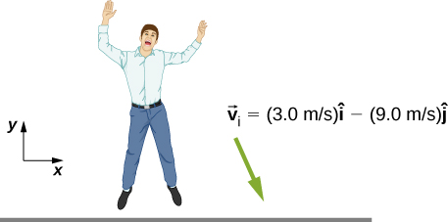

1. First find the impulse on the person from the impact on the ground. Calculate both its magnitude and direction.
2. Find the average force on the feet if the person keeps his leg stiff and straight and his center of mass drops by only 1 cm vertically and 1 cm horizontally during the impact.
3. Find the average force on the feet if the person bends his legs throughout the impact so that his center of mass drops by 50 cm vertically and 5 cm horizontally during the impact.
4. Compare the results of part (b) and (c), and draw conclusions about which way is better.

You will need to find the time the impact lasts by making reasonable assumptions about the acceleration opposite to the motion. Although the force is not constant during the impact, working with constant average force for this problem is acceptable.

Solution

a. , 108° ; b. , ; c. , 

1. Two projectiles of mass  and  are ﬁred at the same speed but in opposite directions from two launch sites separated by a distance *D*. They both reach the same spot in their highest point and strike there. As a result of the impact they stick together and move as a single body afterwards. Find the place they will land.

Solution

 from the midpoint.

1. Two identical objects (such as billiard balls) have a one-dimensional collision in which one is initially motionless. After the collision, the moving object is stationary and the other moves with the same speed as the other originally had. Show that both momentum and kinetic energy are conserved.

Solution

Conservation of momentum demands . We are given that , , and . Combining these equations with the equation given by conservation of momentum gives, which is true, so conservation of momentum is satisfied. Conservation of energy demands . Again combining this equation with the conditions given above give , so conservation of energy is satisfied.

1. A ramp of mass *M* is at rest on a horizontal surface. A small cart of mass *m* is placed at the top of the ramp and released.

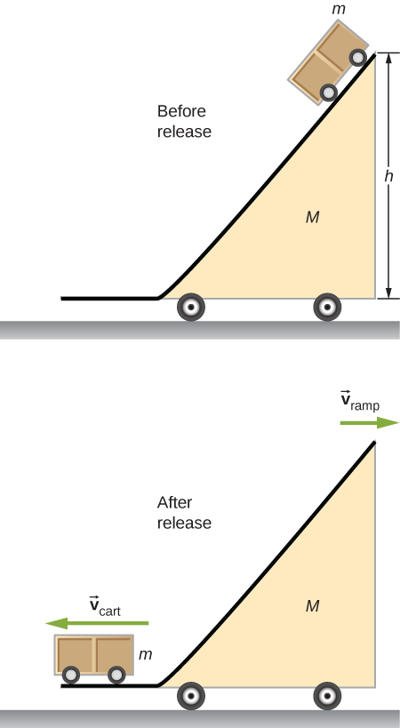

What are the velocities of the ramp and the cart relative to the ground at the instant the cart leaves the ramp?

Solution

]

1. Find the center of mass of the structure given in the figure below. Assume a uniform thickness of 20 cm, and a uniform density of 

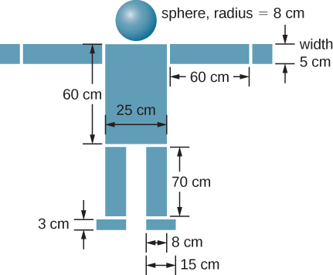

Solution

Assume origin on centerline and at floor, then 

This file is copyright 2016, Rice University. All Rights Reserved.